East Lancashire Hospice 10K Route
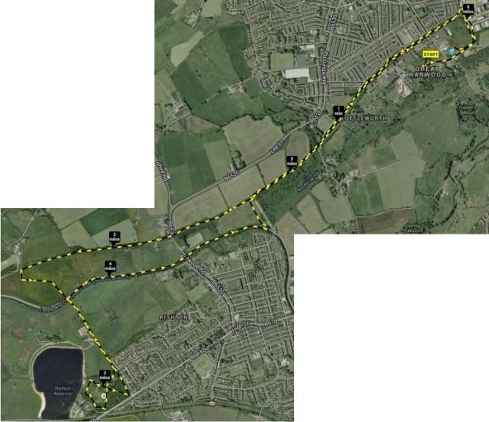
Route description

Heys Lane Industrial Estate
on to the white path towards
Cut Lane at Rishton.
Up Cut Lane into Cut Park
at Rishton.

Around Cut Park on to
Cut Lane down to
Leeds Liverpool Canal
and then on to towpath
towards Great Harwood

Leave towpath at Spring Street
and back to white path towards Great Harwood.

Then head back on to Heys Lane Industrial Estate to finish at Gaskell Motor Bodies.

