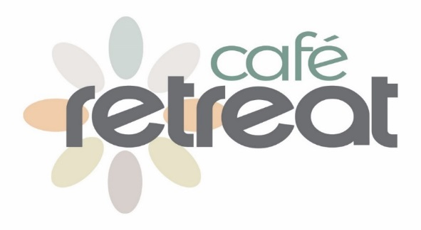
Festive Afternoon Tea Menu
£15 per person

A Selection of Miniature Sandwiches

Miniature Pies and Quiches
Homemade cheese rolls, chorizo, pork and apple sausage rolls, caramelised onion and tomato quiche

A Selection of Cakes and Pastries
Including Chocolate Mandarin Meringue, Miniature Christmas cake and Mince Pie

